Jean Nogas BSIT-3A ACT#3 Sir. Soriano

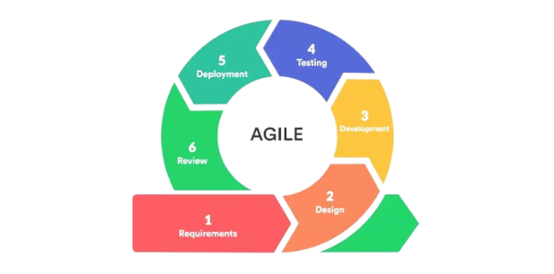Agile SDLC Model

I chose the Agile SDLC Method for my personal blog because I think it can really change how I blog. Agile is all about being flexible, doing things bit by bit, and listening to feedback to make things better. This fits well with how blogs work because they're always changing. With Agile, I can break down my blog tasks into smaller parts and work on them one at a time. This means I can update my blog more often, keeping my readers interested in what's coming next. Plus, Agile reminds me to ask my readers what they think regularly. Their feedback helps me understand what they like and what they don't, so I can make my blog better for them. Overall, using Agile for my blog can make it more flexible, responsive, and better overall. By taking small steps, listening to feedback, and always learning, I hope to make my blog a really cool place for my readers.